The restless earth
SPaG

Q1
Define the following:-
Constructuve plate –
a)
2mk
b)
Oceanic crust –
2mk

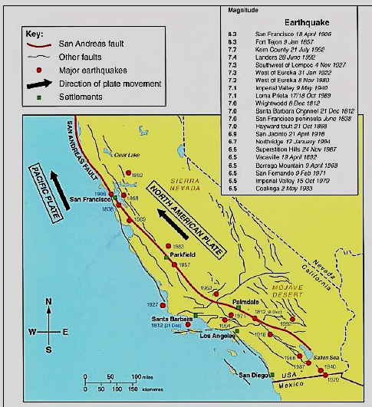
Destructive plate -
c)
2mk

2mk

d)
Plate margin -
2mk
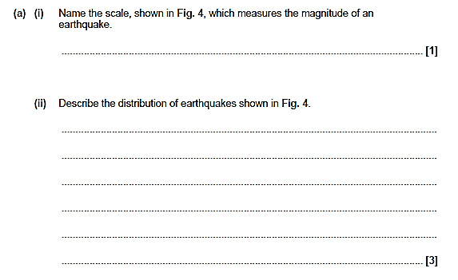
Q3
Q2
2mk
The restless earth
SPaG
Q1
Define the following:-
The Mantle –
a)
2mk
b)
Continental crust –
2mk
c)
Fault line -
2mk

Oceanic trench -
d)
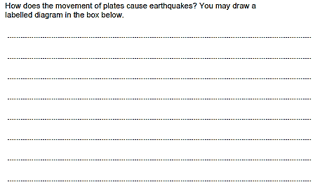
Q2
2mk
4mk

The restless earth
SPaG

Q1
Define the following:-
Focus –
a)
2mk
b)
Epicentre –
2mk
c)
Richter scale -
2mk

Mercalli scale -
d)
Q2
2mk
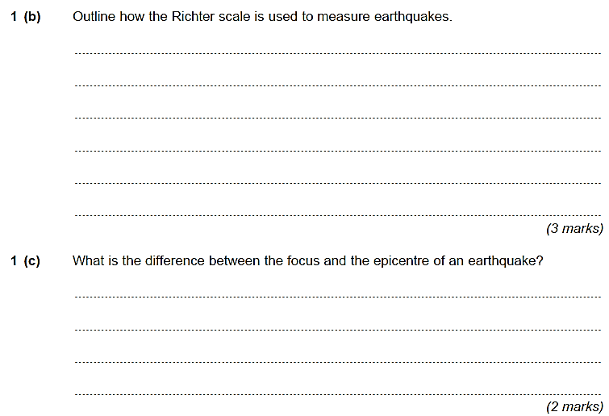
Q4
Q3
Q3

The restless earth
SPaG

Define the following:-
Q1
Shield volcano –
a)
2mk
b)
Composite volcano –
2mk

c)
Super volcano -
2mk

Tsunami -
2mk
d)

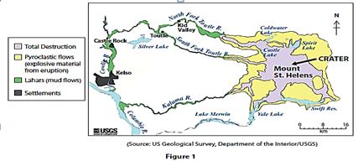
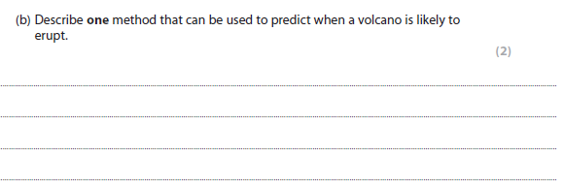
Q3
Q2
The restless earth
SPaG

Define the following:-
Q1
Seismomometer –
a)
2mk
b)
Magnitude –
2mk

c)
Shock waves -
2mk

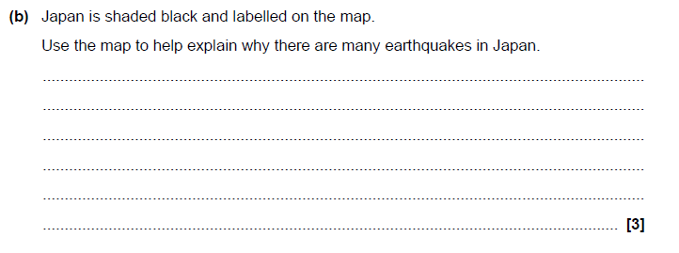
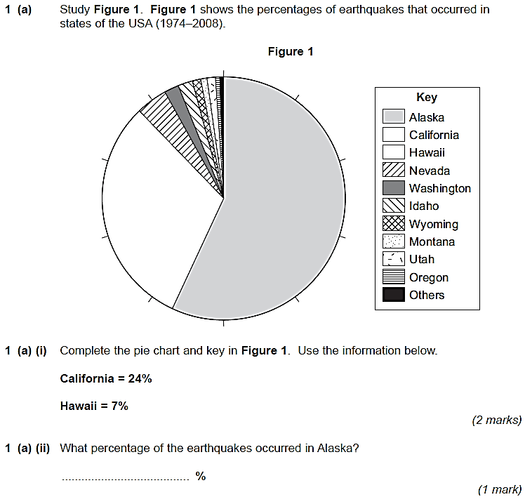
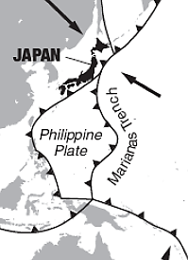
Q3
Q2
Figure 1 – Percentages of earthquakes in the USA
Q4

