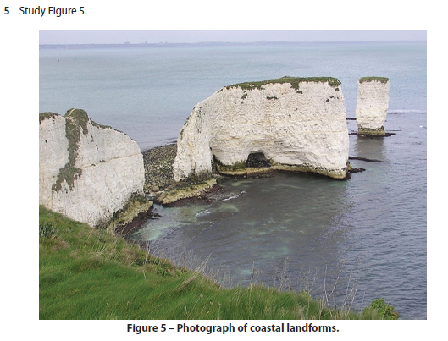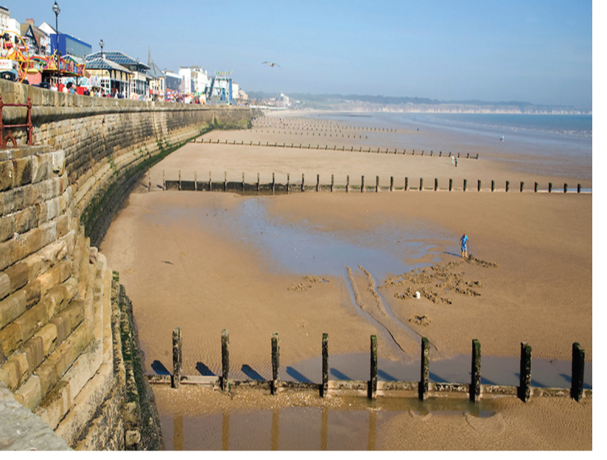De Aston School Geography Department – Coastal management

3mk

2mk

1mk

Name the feature in the photograph A?

Describe how that feature was formed

Name the two types of coastal management shown in picture B?