Hypothesis/Question: -
Year 11 Geography Field work
De Aston School

How does Lincoln meet the needs of different groups of people?
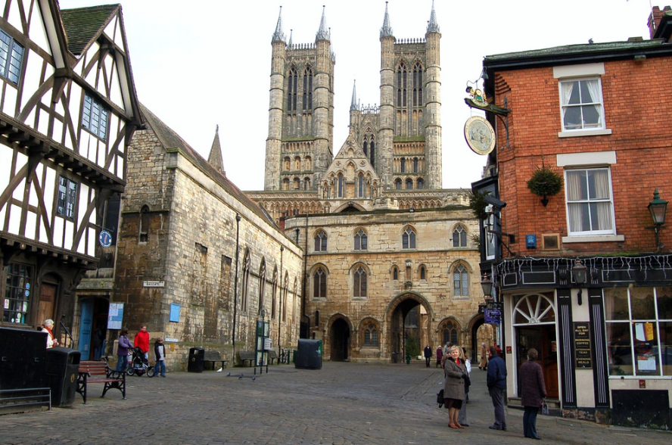

Project structure

- Introduction – Background information
- Methodology – Data collection
- Presentation – Graphs and map work
- Analysis – What does your data show?
- Conclusion – How far does your project answer the question
- Evaluation – What could you have improved?

- Introduction

Lincoln is a Cathedral City and the county town of Lincolnshire and is one of the UK's largest counties. Part of the East Midlands, Lincolnshire sits on the East coast of England, to the north of Norfolk and the south of Yorkshire - nestled between the Humber and the Wash.
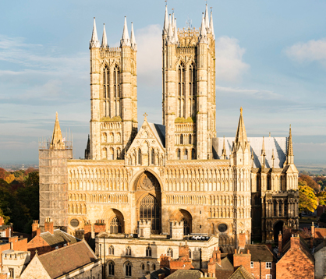
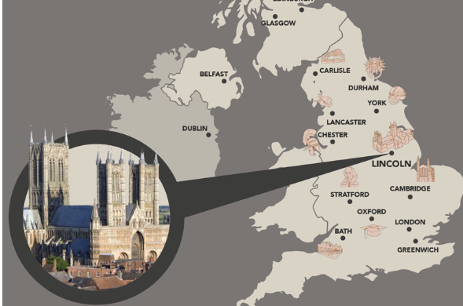

The Cathedral Quarter, High Street and Brayford Pool is home to an abundance of independent retailers, a tempting selection of palaces to eat and drink in and luxurious, independent hotels and guest houses across the city.

- Methodology
Sampling
Task 2- Tick the sampling method for each type of data collection method

Sampling method | Explanation | Data collection method
 |  | Pedestrian counts | Land use/ amenity survey | Bi-polar survey | Questionnaire
Random sampling | Selecting a person to interview or site to measure, at random. Random sampling is unbiased as particular people or places are not specifically selected.
Systematic sampling | Collecting data in an ordered or regular way, e.g. every 5 metres or every fifth person.
Stratified sampling | Dividing sampling into groups, e.g. three sites from each section of coastline, or five people from each age range. It is possible to combine stratified sampling with random and systematic sampling.

Pedestrian counts method
In each location stand for a 5-minute period tally the pedestrians and multiply the number by 12 for an hourly rate. This could be conducted at differing times of the day or year and it can be useful to have some secondary data for comparison. Counting pedestrian in a city centre might provide some information to compare changes over time or in a day.

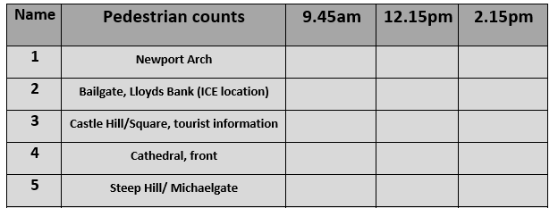

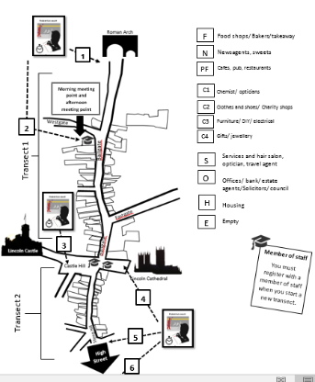
Measuring land use/ amenity function
Along each of the transects use a systematic sampling strategy to select locations to record land use function. You may wish to restrict your sample by recording ground floor land use only. Land use is categorised for ease of analysis. A popular way of doing this is to use the RICEPOTS system or other categories.
Bi-polar surveys/ environmental quality survey
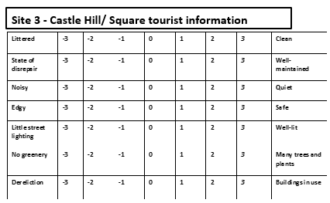
One method is to use a bi-polar survey, this involves choosing pairs of opposite characteristics - for example lots of cans/paper and litter-free, and associated these with a scale score

Questionnaires
Questionnaires or informal chats with the public might ask the following
- ”How long have you lived here?”
- “What do you like/not like about the city?”
- “How has the city changed in the time you have lived here?”
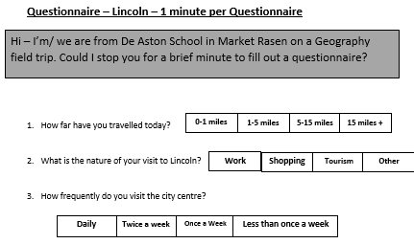
They are usually made up of a mixture of closed and open questions. Closed questions will consist of categories. Open questions will usually ask for an opinion.

Secondary data
- Use of old maps/photographs to compare past and present landforms and profiles
- Use of geology maps
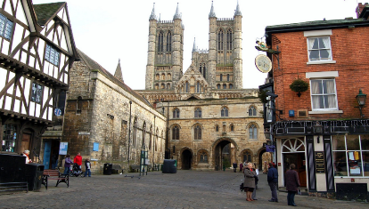
- O.S. maps and aerial photographs
- Websites

Risk assessment
Task 3 – Complete the question below about the risk assessment.

ASSESSMENT | 6-10  LOW RISK | 11-19  MEDIUM RISK | 20-25  HIGH RISK | 26-30  UNACCEPTABLE RISK
DEFINITION | The possibility and nature of an accident occurring are not substantially different from those encountered in every day experience. | The hazards encountered are outside the groups’ experience, but by adopting principles of safe practice should bring them to an acceptable level. | The hazards encountered are either extreme or very much beyond the every day experience of the group. The repercussions of an accident could lead to serious consequences. | The hazards encountered are far beyond the experience of the group and the Party Leader. The visit should not proceed.

