A brief history of climate change
As the UN climate summit in Copenhagen approaches, BBC News environment correspondent Richard Black traces key milestones, scientific discoveries, technical innovations and political action.
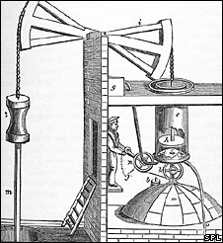
The Newcomen Engine foreshadowed industrial scale use of coal
1712 - British ironmonger Thomas Newcomen invents the first widely used steam engine, paving the way for the Industrial Revolution and industrial scale use of coal.
1800 - world population reaches one billion.
1824 - French physicist Joseph Fourier describes the Earth's natural "greenhouse effect". He writes: "The temperature [of the Earth] can be augmented by the interposition of the atmosphere, because heat in the state of light finds less resistance in penetrating the air, than in re-passing into the air when converted into non-luminous heat."
1861 - Irish physicist John Tyndall shows that water vapour and certain other gases create the greenhouse effect. "This aqueous vapour is a blanket more necessary to the vegetable life of England than clothing is to man," he concludes. More than a century later, he is honoured by having a prominent UK climate research organisation - the Tyndall Centre - named after him.
1886 - Karl Benz unveils the Motorwagen, often regarded as the first true automobile.
1896 - Swedish chemist Svante Arrhenius concludes that industrial-age coal burning will enhance the natural greenhouse effect. He suggests this might be beneficial for future generations. His conclusions on the likely size of the "man-made greenhouse" are in the same ballpark - a few degrees Celsius for a doubling of CO2 - as modern-day climate models.
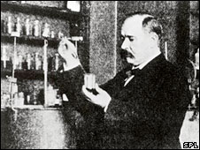
Svante Arrhenius unlocked the man-made greenhouse a century ago
1900 - another Swede, Knut Angstrom, discovers that even at the tiny concentrations found in the atmosphere, CO2 strongly absorbs parts of the infrared spectrum. Although he does not realise the significance, Angstrom has shown that a trace gas can produce greenhouse warming.
1927 - carbon emissions from fossil fuel burning and industry reach one billion tonnes per year.
1930 - human population reaches two billion.
1938 - using records from 147 weather stations around the world, British engineer Guy Callendar shows that temperatures had risen over the previous century. He also shows that CO2 concentrations had increased over the same period, and suggests this caused the warming. The "Callendar effect" is widely dismissed by meteorologists.
1955 - using a new generation of equipment including early computers, US researcher Gilbert Plass analyses in detail the infrared absorption of various gases. He concludes that doubling CO2 concentrations would increase temperatures by 3-4C.
1957 - US oceanographer Roger Revelle and chemist Hans Suess show that seawater will not absorb all the additional CO2 entering the atmosphere, as many had assumed. Revelle writes: "Human beings are now carrying out a large scale geophysical experiment..."
1958 - using equipment he had developed himself, Charles David (Dave) Keeling begins systematic measurements of atmospheric CO2 at Mauna Loa in Hawaii and in Antarctica. Within four years, the project - which continues today - provides the first unequivocal proof that CO2 concentrations are rising.
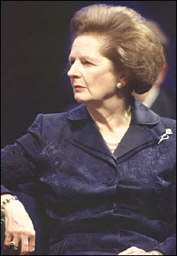
Change in future is likely to be more fundamental and more widespread than anything we have known hitherto
Margaret Thatcher
1960 - human population reaches three billion.
1965 - a US President's Advisory Committee panel warns that the greenhouse effect is a matter of "real concern".
1972 - first UN environment conference, in Stockholm. Climate change hardly registers on the agenda, which centres on issues such as chemical pollution, atomic bomb testing and whaling. The United Nations Environment Programme (Unep) is formed as a result.
1975 - human population reaches four billion.
1975 - US scientist Wallace Broecker puts the term "global warming" into the public domain in the title of a scientific paper.
1987 - human population reaches five billion
1987 - Montreal Protocol agreed, restricting chemicals that damage the ozone layer. Although not established with climate change in mind, it has had a greater impact on greenhouse gas emissions than the Kyoto Protocol.
1988 - Intergovernmental Panel on Climate Change (IPCC) formed to collate and assess evidence on climate change.
1989 - UK Prime Minister Margaret Thatcher - possessor of a chemistry degree - warns in a speech to the UN that "We are seeing a vast increase in the amount of carbon dioxide reaching the atmosphere... The result is that change in future is likely to be more fundamental and more widespread than anything we have known hitherto." She calls for a global treaty on climate change.
1989 - carbon emissions from fossil fuel burning and industry reach six billion tonnes per year.
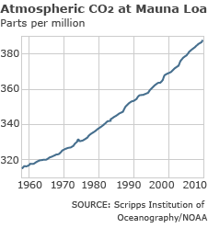
The CO2 concentration, as measured at Mauna Loa, has risen steadily
1990 - IPCC produces First Assessment Report. It concludes that temperatures have risen by 0.3-0.6C over the last century, that humanity's emissions are adding to the atmosphere's natural complement of greenhouse gases, and that the addition would be expected to result in warming.
1992 - at the Earth Summit in Rio de Janeiro, governments agree the United Framework Convention on Climate Change. Its key objective is "stabilization of greenhouse gas concentrations in the atmosphere at a level that would prevent dangerous anthropogenic interference with the climate system". Developed countries agree to return their emissions to 1990 levels.
1995 - IPCC Second Assessment Report concludes that the balance of evidence suggests "a discernible human influence" on the Earth's climate. This has been called the first definitive statement that humans are responsible for climate change.
1997 - Kyoto Protocol agreed. Developed nations pledge to reduce emissions by an average of 5% by the period 2008-2012, with wide variations on targets for individual countries. US Senate immediately declares it will not ratify the treaty.
1998 - strong El Nino conditions combine with global warming to produce the warmest year on record. The average global temperature reached 0.52C above the mean for the period 1961-1990 (a commonly-used baseline).
1998 - publication of the controversial "hockey stick" graph indicating that modern-day temperature rise in the northern hemisphere is unusual compared with the last 1,000 years. The work would later be the subject of two enquiries instigated by the US Congress.
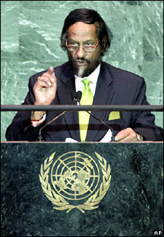
Rajendra Pachauri's IPCC netted the Nobel Peace Prize in 2007
1999 - human population reaches six billion.
2001 - President George W Bush removes the US from the Kyoto process.
2001 - IPCC Third Assessment Report finds "new and stronger evidence" that humanity's emissions of greenhouse gases are the main cause of the warming seen in the second half of the 20th Century.
2005 - the Kyoto Protocol becomes international law for those countries still inside it.
2005 - UK Prime Minister Tony Blair selects climate change as a priority for his terms as chair of the G8 and president of the EU.
2006 - the Stern Review concludes that climate change could damage global GDP by up to 20% if left unchecked - but curbing it would cost about 1% of global GDP.
2006 - carbon emissions from fossil fuel burning and industry reach eight billion tonnes per year.
2007 - the IPCC's Fourth Assessment Report concludes it is more than 90% likely that humanity's emissions of greenhouse gases are responsible for modern-day climate change.
2007 - the IPCC and former US vice-president Al Gore receive the Nobel Peace Prize "for their efforts to build up and disseminate greater knowledge about man-made climate change, and to lay the foundations for the measures that are needed to counteract such change".
2007 - at UN negotiations in Bali, governments agree the two-year "Bali roadmap" aimed at hammering out a new global treaty by the end of 2009.
2008 - half a century after beginning observations at Mauna Loa, the Keeling project shows that CO2 concentrations have risen from 315 parts per million (ppm) in 1958 to 380ppm in 2008.
2008 - two months before taking office, incoming US president Barack Obama pledges to "engage vigorously" with the rest of the world on climate change.
2009 - China overtakes the US as the world's biggest greenhouse gas emitter - although the US remains well ahead on a per-capita basis.
2009 - 192 governments convene for the UN climate summit in Copenhagen.

