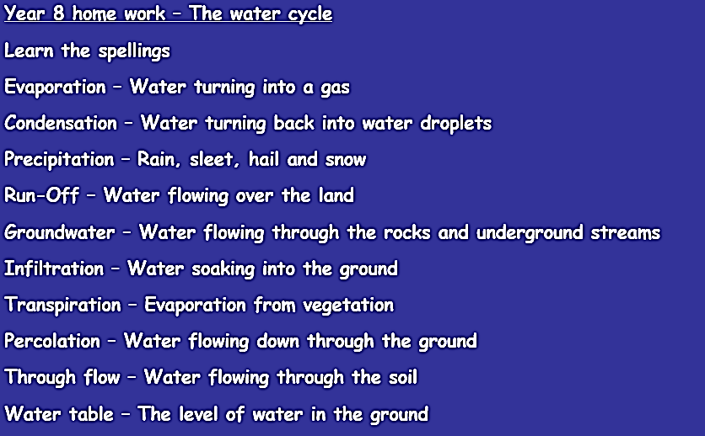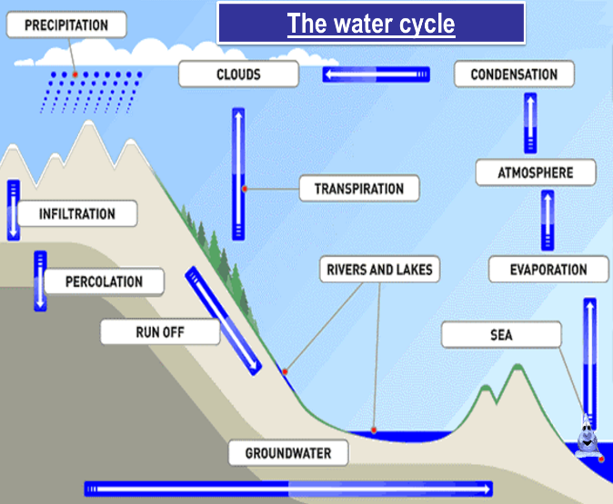

**Drainage basins**

**Rivers and water revision sheets**

**The water cycle**

****[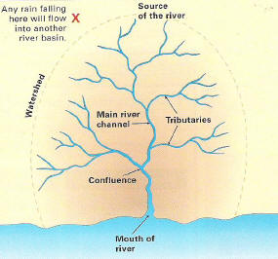](http://www.google.co.uk/url?sa=i&rct=j&q=&esrc=s&source=images&cd=&cad=rja&uact=8&ved=0ahUKEwiEjKCTuNrRAhVDDMAKHWuxAs0QjRwIBw&url=http%3A%2F%2Fwww.sln.org.uk%2Fgeography%2Fschools%2Fblythebridge%2FGCSERevisionRiversDB.htm&psig=AFQjCNEIAZTgMB3LzHvF7ik0fyY760CxIA&ust=1485335515622486)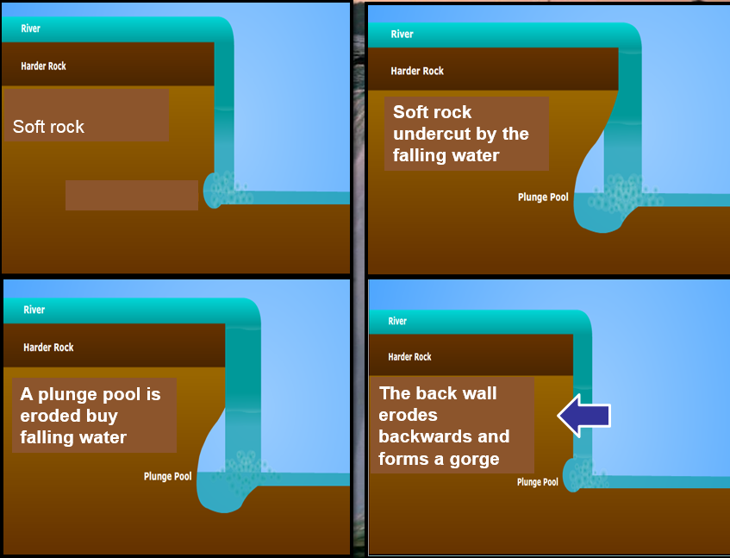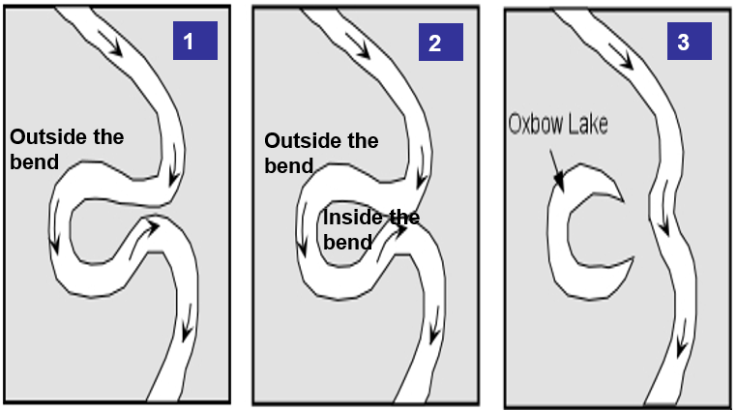

**Formation of an Oxbow Lake**

As the river erodes to the right side then the left side, it forms large bends, and then horseshoe-like loops called **meanders**. The force of the water **erodes** and undercuts the river bank on the outside of the bend where water flow has most energy. On the **inside** of the bend, where the river flow is slower, material is **deposited**. Over time the horseshoe become tighter, until the ends become very close together. As the river breaks through, eg during a flood the loop is cut off to form a lake. The cut-off loop is called an **oxbow lake**.

**Meanders and ox-bow lakes**

**Waterfalls**



**Formation of a waterfall**

**The soft rock erodes more quickly,** [undercutting](http://www.bbc.co.uk/bitesize/ks3/geography/physical_processes/rivers_flooding/revision/6/) **the hard rock. The hard rock is left** [overhanging](http://www.bbc.co.uk/bitesize/ks3/geography/physical_processes/rivers_flooding/revision/6/) **and unsupported, it eventually collapses. The fallen rocks crash into the** [plunge pool](http://www.bbc.co.uk/bitesize/ks3/geography/physical_processes/rivers_flooding/revision/6/)**. They swirl around, causing more erosion. Over time, this process is repeated and the waterfall moves upstream. A steep-sided** [gorge](http://www.bbc.co.uk/bitesize/ks3/geography/physical_processes/rivers_flooding/revision/6/) **is formed as the waterfall retreats.**

[www.deaston.org](http://www.deaston.org)

**Password - hurricane**