Compass directions
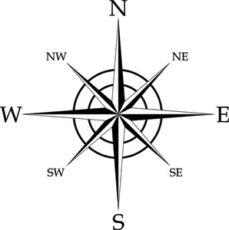
Starting at the top and moving clockwise the directions on a compass or map are:

Points of a compass
- North - Naughty
- East - Elephants
- South - Squirt
- West - Water

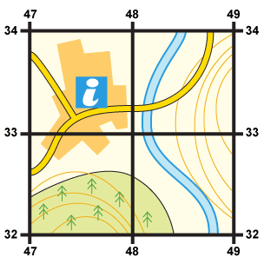
4 figure grid references
- Start at the left-hand side of the map and go east until you get to the easting crossing through the bottom-left-hand corner of the square you want. Write this number down.
- Move north until you get to the northing crossing the bottom-left-hand corner of the square you want. Look at the number of this grid line and add it to the two-digit number you already have. This is your four-figure grid reference.
In this case, the tourist information office is in grid square 4733.

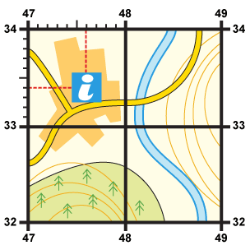
6 figure grid reference
- First, find the four-figure grid reference but leave a space after the first two digits. When you get to the easting at the left-hand side of the grid square you want, keep moving east and estimate or measure how many tenths across your symbol lies. Write this number after the first two digits.
- Next, move north from the bottom-left-hand corner of your grid square and estimate how many tenths your symbol is from this point. Put them together to create a six figure grid reference.
In this instance, the tourist information office is located at 476334.

Map Symbols
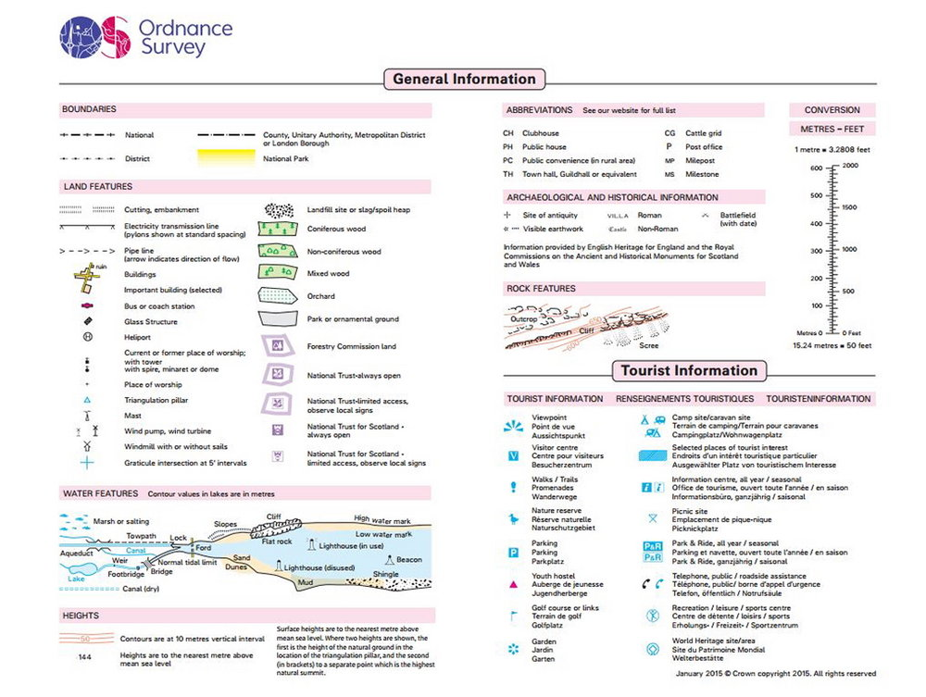
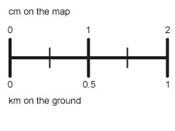
Scale on a map
The scale of a map allows a reader to calculate the size, height and dimensions of the features shown on the map, as well as distances between different points.

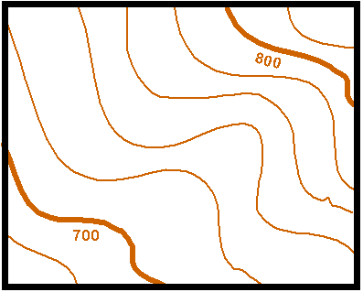
Contour lines
Contours will show you where the hills and valleys are on the map. Contours will often show changes in height of 5 or 10 metres. The closer the contours are together the steeper the slope is. If the contours are far apart, you might be looking at a flat flood plain.

