Challenge of weather and climate
SPaG

Q1
Define the following:-
Low pressure –
a)
2mk
b)
High pressure –
2mk
c)
Isobars -
2mk
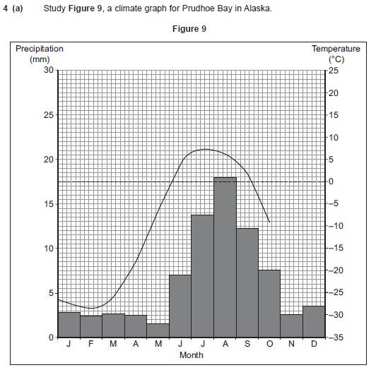

2mk
Q3
Q2
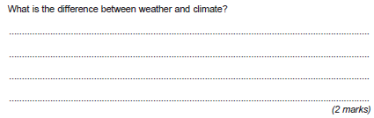
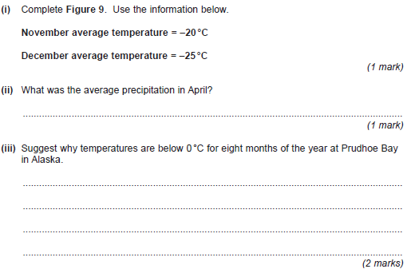
Q4
Challenge of weather and climate
SPaG

Q1
Define the following:-
Depression –
a)
2mk
b)
Anticyclone –
2mk
c)
Convectional rainfall –
2mk

d)
Relief rainfall -
2mk
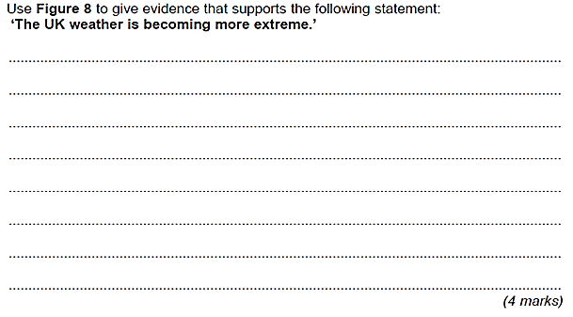
Q2

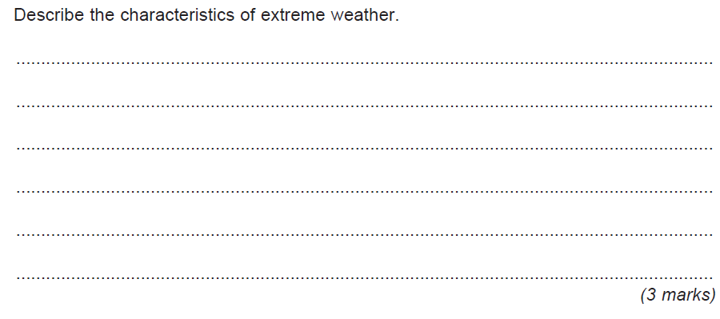
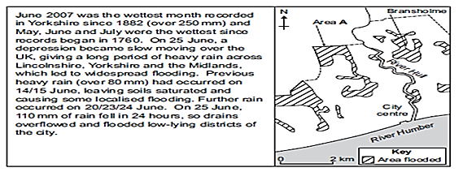
Q3
Figure 8
Challenge of weather and climate
SPaG

Q1
Define the following:-
The Coriolis force –
a)
2mk
b)
Hurricane –
2mk
c)
Storm surge -
2mk
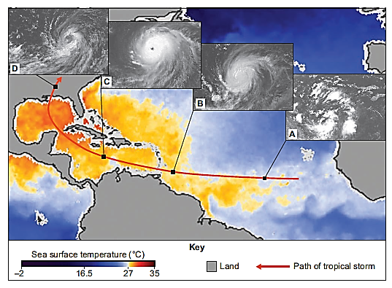
Figure 3

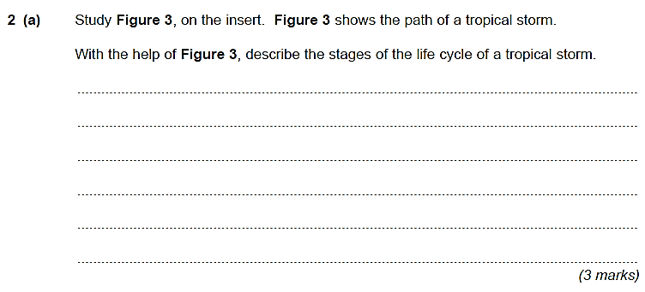
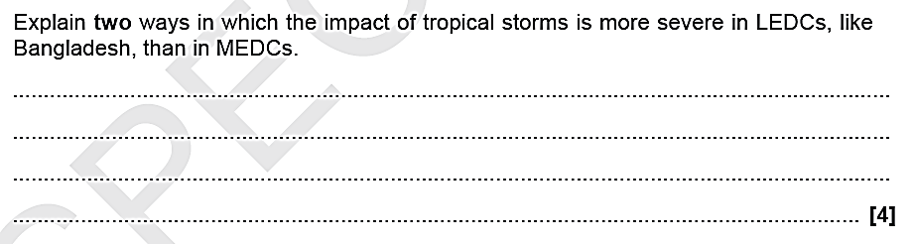
Q2
Q3
Challenge of weather and climate
SPaG

Q1
Define the following:-
Hurricane eye –
a)
2mk
b)
Saffir-Simpson scale –
2mk
c)
Long term impacts -
2mk
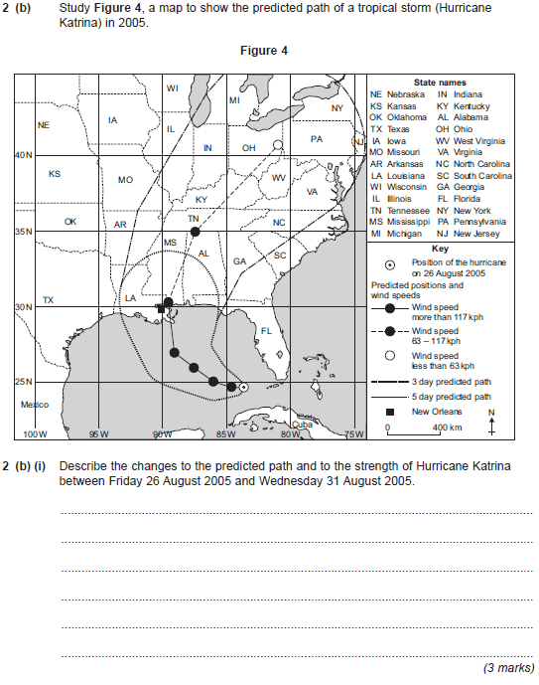
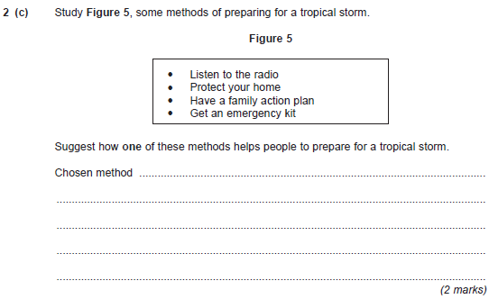
Q3
Q2
Study figure 4
Challenge of weather and climate
Q1
SPaG
Define the following:-
Greenhouse effect –
a)
2mk
b)
Climate change –
2mk
c)
Global warming -
2mk
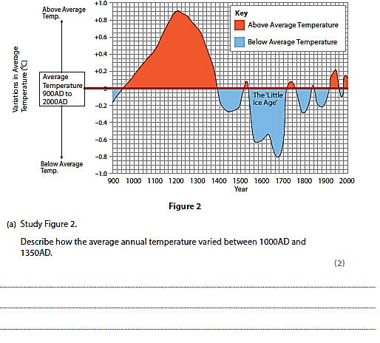
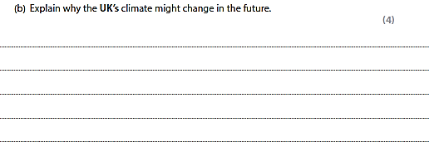
Q3
Q2
Challenge of weather and climate
Define the following:-
Q1
SPaG

Solar output –
a)
2mk
b)
Kyoto agreement –
2mk
c)
Extreme weather -
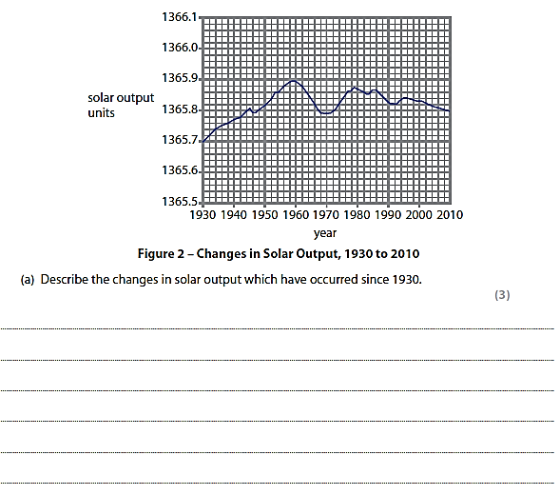
2mk
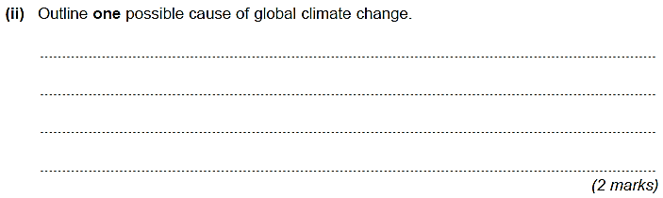
Q3
Q2

