The coastal zone homework questions

Q1
Define the following:-
Destructive waves –
a)
2mk
b)
Wave-cut platform –
2mk
c)
Sea stack -
2mk
Q2
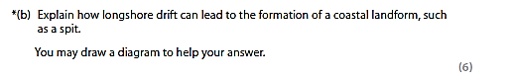
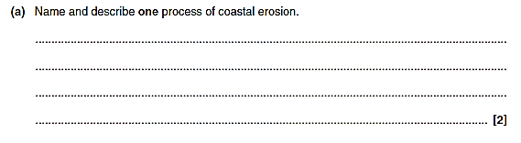
Q3

Q3

The coastal zone homework questions
Q1

Define the following:-
Weathering –
a)
2mk
b)
Attrition –
2mk
c)
Wave cut notch -
2mk

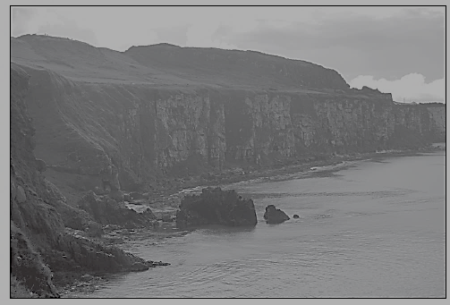
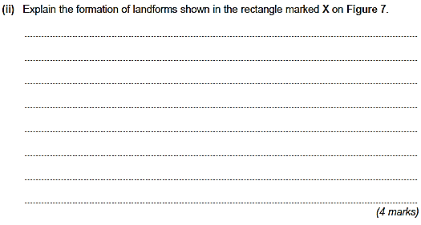
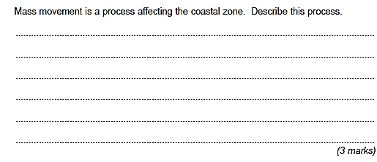
Q3
Q2
The coastal zone homework questions
Q1

Define the following:-
Constructive waves –
a)
2mk
b)
Saltation –
2mk
c)
A Beach -
2mk

A Spit -
Q2
2mk
d)
Q3
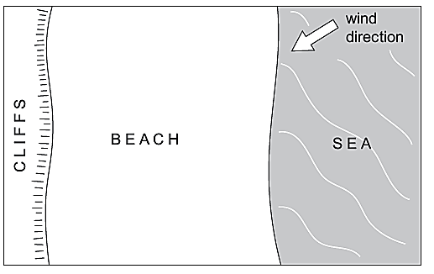
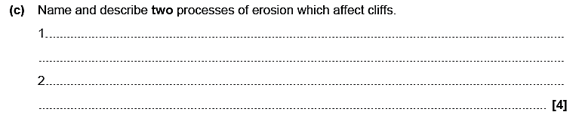
The coastal zone homework questions

Q1
Define the following:-
Hard engineering –
a)
2mk
b)
Soft engineering –
2mk
c)
Managed retreat -
2mk

Groynes -
d)
2mk

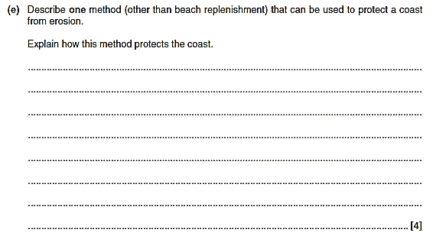
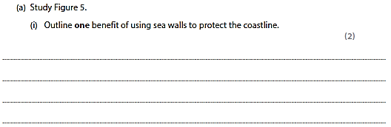
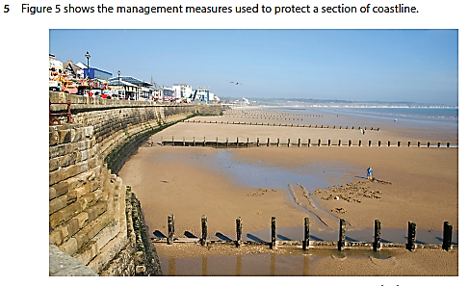
Q3
Q2

