Year 9 Geography Homework - Coasts
Find out what this coastal feature is and where it is located?
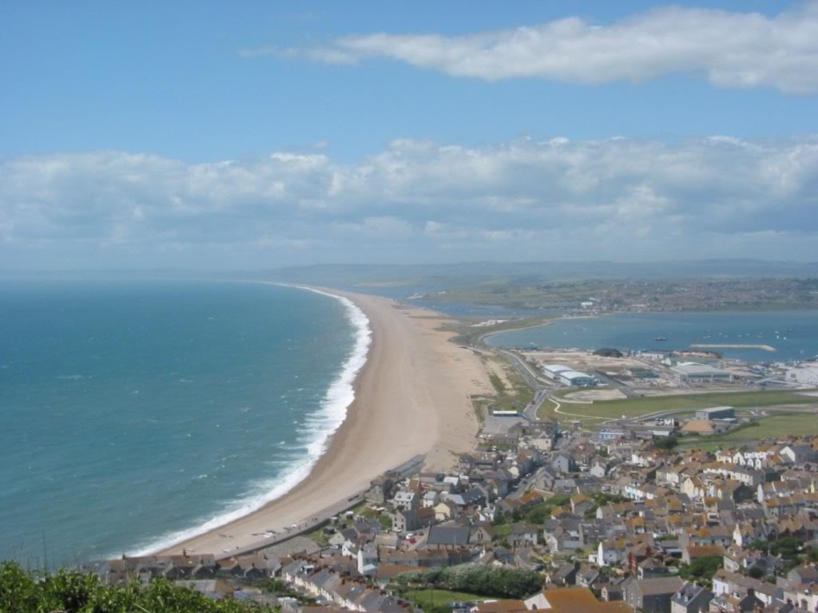
Year 9 Geography Homework - Coasts
Find out what this coastal feature is and where it is located?

