De Aston School Geography Department - Erosion

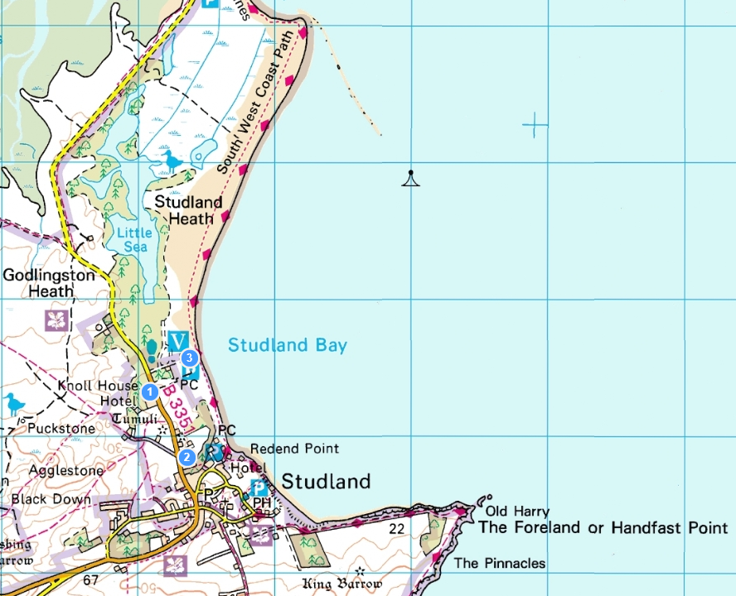

86

85

84

83

82

Questions

1. Using a four figure grid reference, which square is Studland Bay visitors centre located?
2. Using a four figure grid reference, which square is the car park for Studland bay?
3. What is the number of the B road that is located next to Studland bay?
4. Using a 4 figure grid reference what is the location the marshland located by the arrow on the map?
5. Using a 6 figure grid reference what is the location of old Harry circled above?
6. Using a 6 figure grid reference what is the location of the beacon circled in the sea?
7. If 2cm = 1 km how long is the stretch of coastline shown on the map?
8. If Studland bay is feature known as a bay, what is the feature named Foreland or Handfast point?



02 03 04 05 06 07