HW3 – Year 8 Settlement – Lincoln Map description
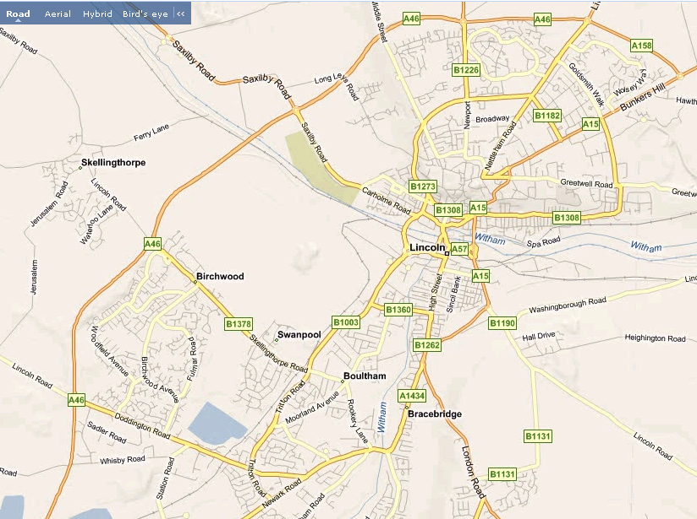
Newport, Burton Road and Nettleham Road Glebe Park
Monks Road
Carholme Road, and Sincil Bank
Boultham
BirchwoodPark
Bunkers hill and Glebe Park
N
KEY
CBD
Inner City
Inner Suburbs
Outer Suburbs
Describe the location of different parts of Lincoln ( CBD, Inner city etc…) using the compass point and labels to help. (8mks)

