HW 3 - Y7 Geography Homework – Map Symbols

Find out ten map symbols and what they show on the map below
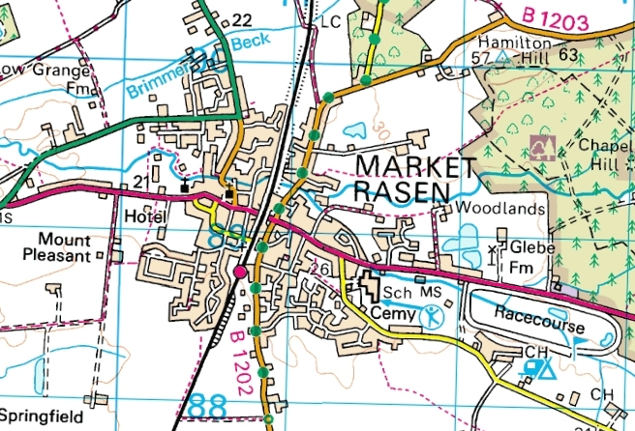

Symbol
Name of symbol
Symbol

