HW3 – Year 9 Population – Describing population pyramids
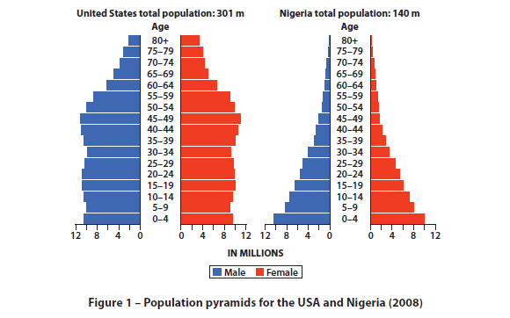

Describe the differences between these two population pyramids?

