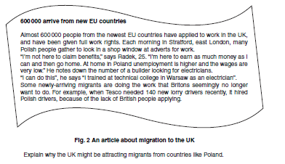
HW6 – Year 9 Population – Migration
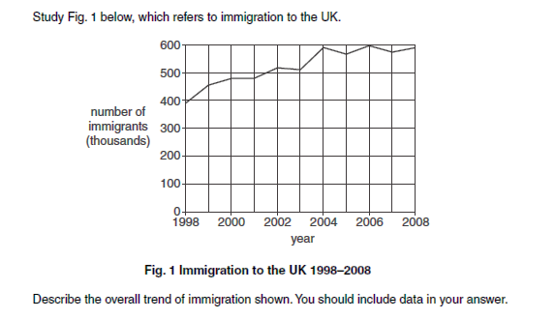
Q1 - Describe the overall trend of migration shown. You should include figures/data in your answer. (2mks)

Q2 -Read Fig 2 and explain why the UK might be attracting migrants from countries such as Poland? (4mks)

