HW5 – Year 9 Population – Population control
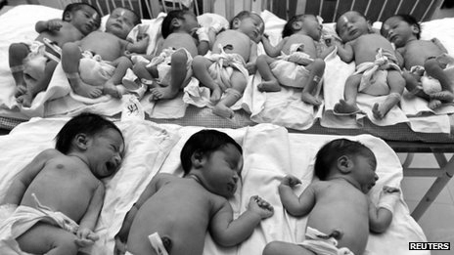

Q1- Describe how some countries have tried to control population growth?

