The Changing economic world
Q1
Define the following:-
Birth rate –
a)
2mk
b)
Natural increase –
2mk

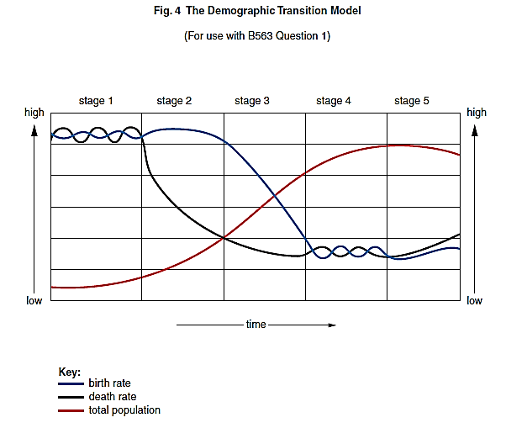
Figure 4 – The demographic transition model

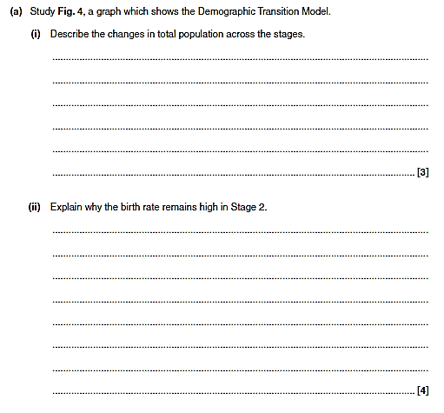
Changing economic world
Q2
DR
BR
NI
Q1
The Changing economic world
Define the following:-
a)
HIC –
2mk
b)
NEE –
2mk
c)
LIC –
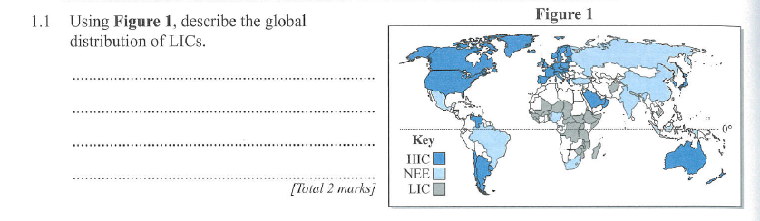
2mk
Q2 Using the map in figure 1, describe the pattern (distribution) of LIC’s. (Use the key and place names)

4mk
Using figure 2, which country is the most developed and why?

4mk

The Changing economic world

Primary industry –
Q1 Define the following terms below:-
2mk
Secondary industry–
2mk
Tertiary industry –
2mk
Q2 Using figure 1.1 describe the Clark Fisher model of industry through time?
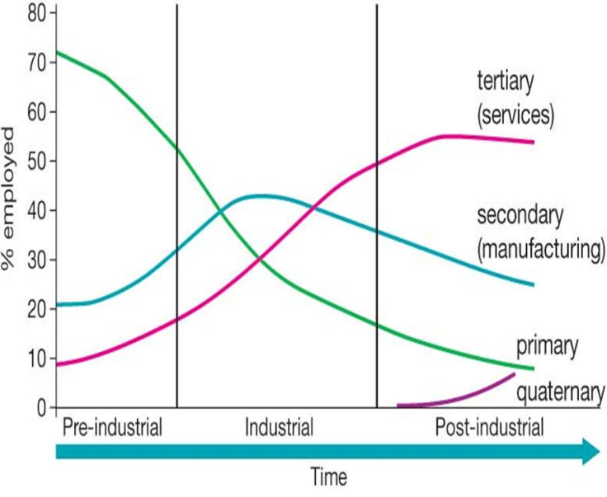
Fig 1.1

4mk

Q3 Describe briefly the four physical factors that affect economic development?

The Changing economic world
DR
BR
NI
Define the following:-
Q1
Aid –
a)
2mk
b)
Fair trade –
2mk
c)
GDP –
2mk
Q2 Compare and contrast the amount of money generated form exports in Nicaragua and the UK?

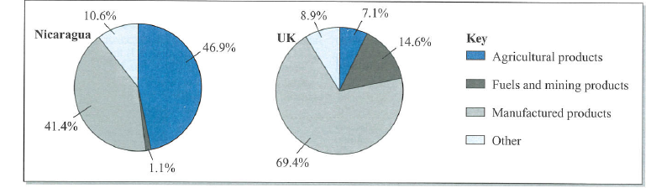

4mk

Q3 Using figure 2 explain and give reasons why Nicaragua is less developed than the UK?

4mk

The Changing economic world
Q1
DR
BR
NI
Define the following:-
The development gap –
2mk

TNC’s –
2mk

4 point rule –
2mk
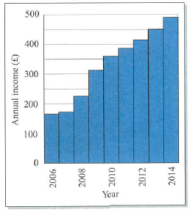
4mk
Q3 Outline how does tourism help with uneven development in LIC’s?
4mk
Q2 Using figure 1.1 describe the graph below which shows the annual income of farmers since the introduction of fair trade.?
Fig 1.1

