Year 9 Geography Homework - Climate Graphs
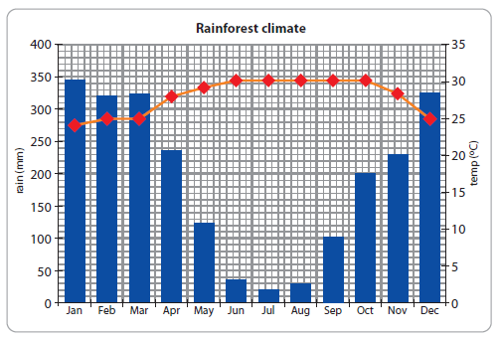
Using the graph above answer the following question:
Describe the temperature and rainfall patterns in Tropical Rainforests.
____________________________________________________________________________________________________________________________________________________________________________________________________________________________________________________________________________________________________________________________________________________________________________________________________________________________________________________________________________________________________________________________________________________________________________________________________________________________________

