

**China’s One child Policy**

**Population pyramids**

**Population revision sheet**

[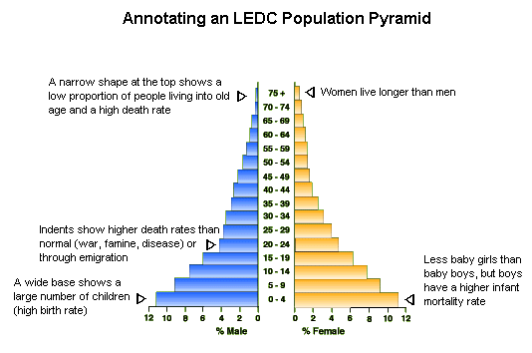](http://www.google.co.uk/url?sa=i&rct=j&q=&esrc=s&source=images&cd=&cad=rja&uact=8&ved=0ahUKEwjhyaHBle_RAhWCORQKHcwaC74QjRwIBw&url=http%3A%2F%2Fgeographyfieldwork.com%2FPopulationStructure.htm&psig=AFQjCNETneXKQtfhszdZoDF-mmtMy-xGMA&ust=1486047712248109)

**Case study: China**

In the late 1970s, the Chinese government introduced a **one-child policy**, which decreed that couples in China could only have one child.

**The one-child policy**

The one-child policy, established in 1979, meant that each couple was allowed just one child. Benefits included increased access to education for all, plus childcare and healthcare offered to families that followed this rule.

**Problems with enforcing the policy:**

* Those who had more than one child didn't receive these benefits and were fined.
* The policy was resisted in rural areas, where it was traditional to have large families.
* In urban areas, the policy has been enforced strictly but remote rural areas have been harder to control.
* Many people claim that some women, who became pregnant after they had already had a child, were forced to have an abortion.
* Women were forcibly sterilised. There appears to be evidence to back up these claims.

**Problems as a result of the policy**

* The birth rate in China has fallen since 1979

Negative impacts :-

* Traditional preference for boys produced a population gender imbalance resulting in 60 million more boys.
* Female babies have ended up homeless or in orphanages, and in some cases killed. In 2000, it was reported that 90 per cent of foetuses aborted in China were female.
* The falling birth rate has resulted in a rise in the relative number of elderly people.
* Fewer people of working age to support the growing number of elderly people.
* In the future China could have an ageing population.

