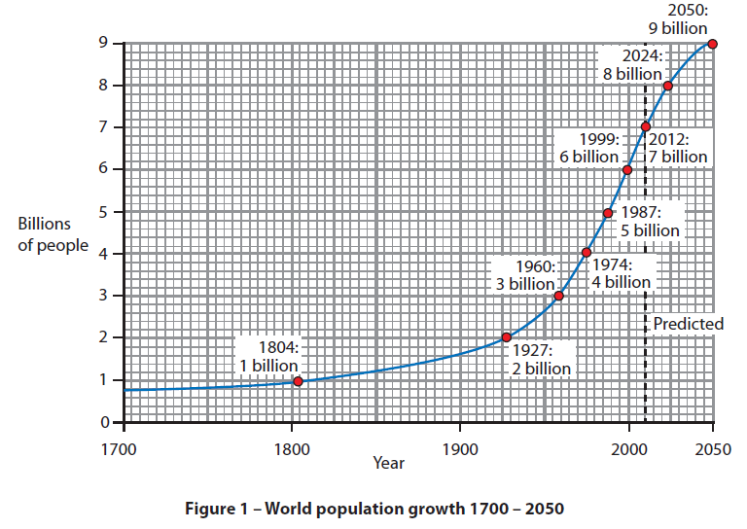
HW3 – Year 9 Population – Describing population growth

Describe the changes on the world population from 1700 – 2012? Try and suggest reasons for the rapid growth. (6mks)

