Hypothesis/Question: -
Year 11 Geography Field work
De Aston School

How do the characteristics of a river change along its long profile?
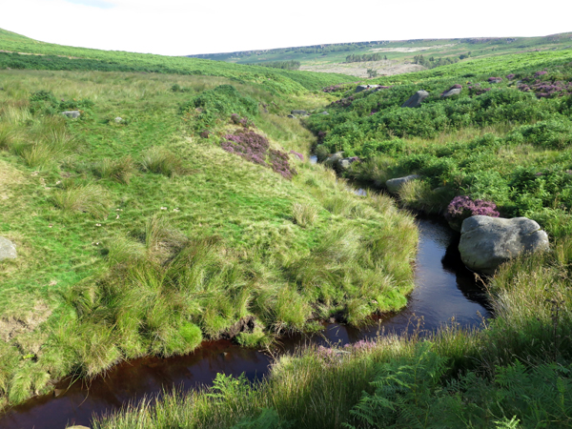

Project structure

- Introduction – Background information
- Methodology – Data collection
- Presentation – Graphs and map work
- Analysis – What does your data show?
- Conclusion – How far does your project answer the question
- Evaluation – What could you have improved?

- Introduction
Burbage valley is 8km north-west of Sheffield. The valley is drained by Burbage brook, a tributary of the R. Derwent. The valley has been carved through two different types of rock - 'millstone grit' and 'shale'. Burbage Brook begins its life high up on the purple heather moors above Sheffield, meandering gently from 410m high with a drop of 200 metres by the time it enters the River Derwent. The river flows though steepening v-shape valleys turns to woodland and the water cascades over rocky boulders as it makes its way down into the Derwent Valley far below where the landscape becomes much flatter and wider.

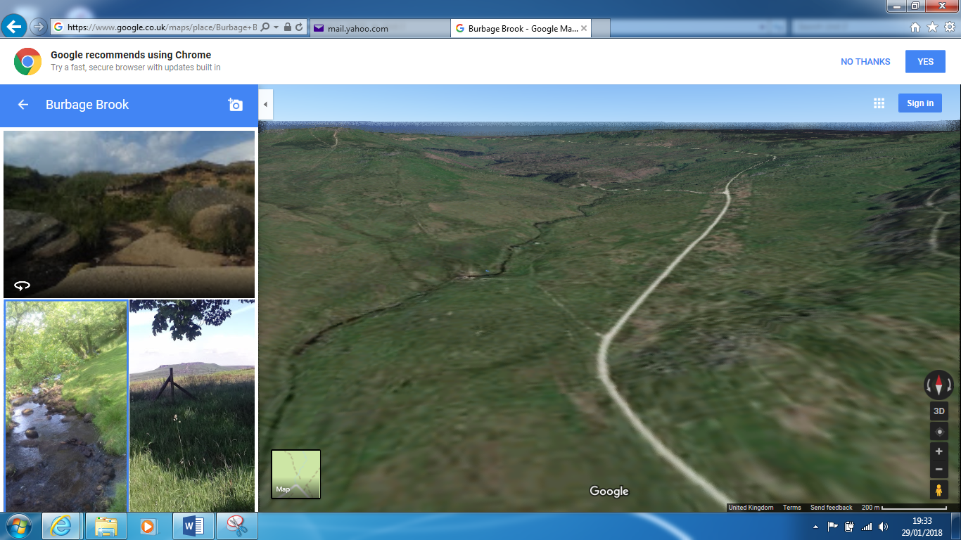
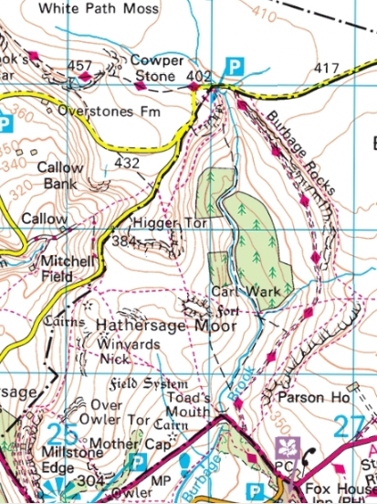
Upper course
Upper course

Middle course
Middle course
Lower course

Lower course

- Fieldwork Methodology

Risk assessment
Task 2 – Complete the question below about the risk assessment.

ASSESSMENT | 6-10  LOW RISK | 11-19  MEDIUM RISK | 20-25  HIGH RISK | 26-30  UNACCEPTABLE RISK
DEFINITION | The possibility and nature of an accident occurring are not substantially different from those encountered in every day experience. | The hazards encountered are outside the groups’ experience, but by adopting principles of safe practice should bring them to an acceptable level. | The hazards encountered are either extreme or very much beyond the everyday experience of the group. The repercussions of an accident could lead to serious consequences. | The hazards encountered are far beyond the experience of the group and the Party Leader. The visit should not proceed.

Sampling

Sampling method | Explanation | Data collection method
 |  | Width and depth | Velocity | Load size | Features tally
Random sampling | Select a site to measure, at random. Random sampling is unbiased as particular people or places are not specifically selected.
Systematic sampling | Collecting data in an ordered or regular way, e.g. every 500 metres.
Stratified sampling | Dividing sampling into groups, e.g. three sites from each section of a coastline or river. It is possible to combine stratified sampling with random and systematic sampling.

Measuring channel width (Quantitative method)
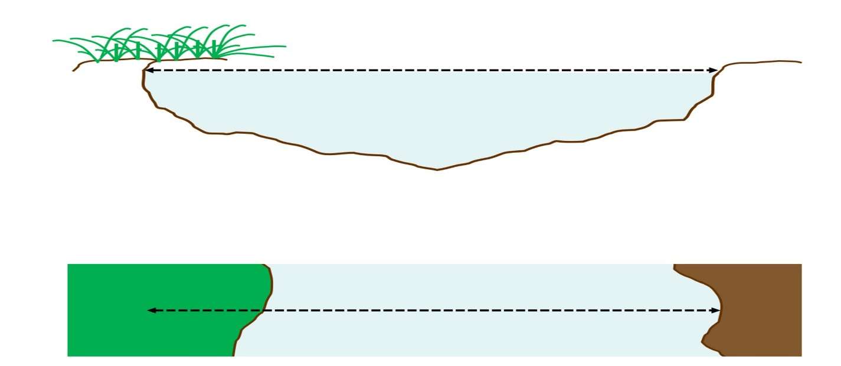
Using a tape measure, hold one end at the point where the water meets the bank one side of the channel. Ensure the tape is not twisted pull the tape measure across the river and measure to the point where the water meets the bank directly opposite.

Measuring channel depth (Quantitative method)
There will probably be some variation in channel depth across the cross profile, so it would not be representative to take a single measurement of depth.
Instead take a number of measurements. How many measurements you chose to take will depend on the variability of the channel depth and the width of the river channel.
Divide width measurement by 10.
e.g. Width=1.20mWidth=1.20m
so width10=0.12mor12cmwidth10=0.12mor12cm
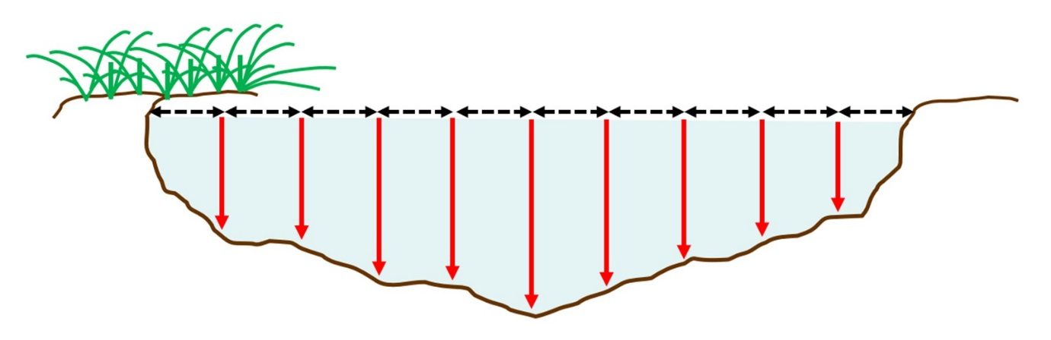
Use this interval to measure at 9 equally spaced points across the channel. With a metre rule measure from the water surface to the river bed.

Measuring velocity (speed) of a river (Quantitative method)

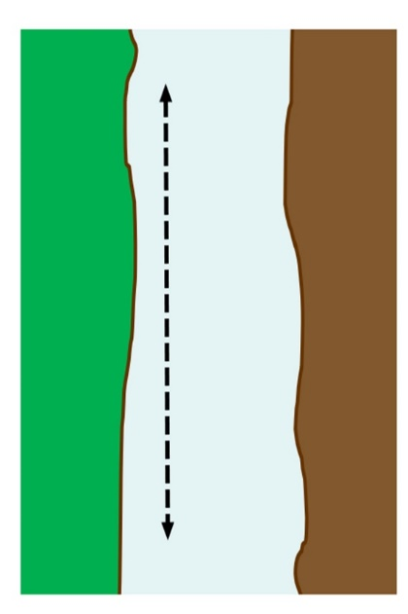
With a flow meter it is possible to obtain a measure of velocity in the field – if you do not have access to a flow meter you can take some measurements using a float (orange) and calculate velocity using the formula:-
Velocity= Distance
Time

- Measure out 10 metres downstream
- Place the float in the water at the upstream end
- Start timing when you let go of the float
10m
- When it reaches the end of your measured stretch stop timing
- Repeat three times and calculate a mean time

Velocity = 10m
Time

Field sketches, landforms and features (Qualitative method)
River landforms can be recorded using annotated field sketches or annotated photographs. These can be used to look at a view of the whole landscape from a given point, or in detail at given features. Here are some useful words to use.
Field sketch scaffold
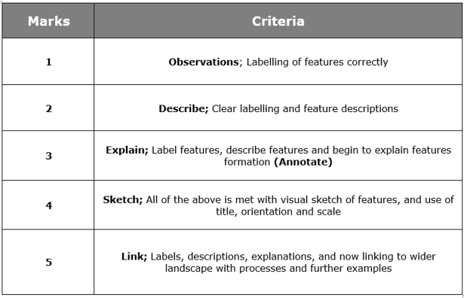

Upper course – 385m above sea level
Small waterfalls and small plunge pools
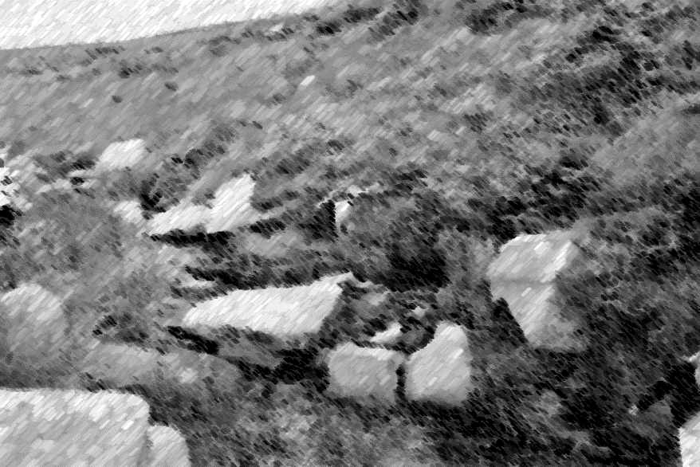
V-shape valley and interlocking spur

Very large bedload, very angular
Very large bedload, very angular

Narrow and steep sided cross section, mainly grassed and high run off rates.
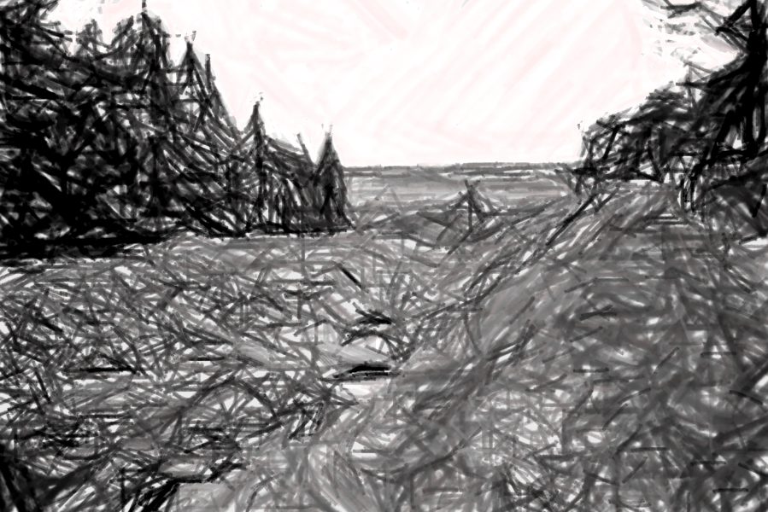
Meander, river cliff, vegetation partially eroded down the bank.
Middle course – 325m above sea level
Interception from the trees slow the movement of water into the rivers

V-shape valley
Large bed load, sub rounded

Width becomes wider in the middle course and land is flatter outside of the main river cross section.

Meander, point bar (slip off slope) and river cliff

Lower course – 280m above sea level
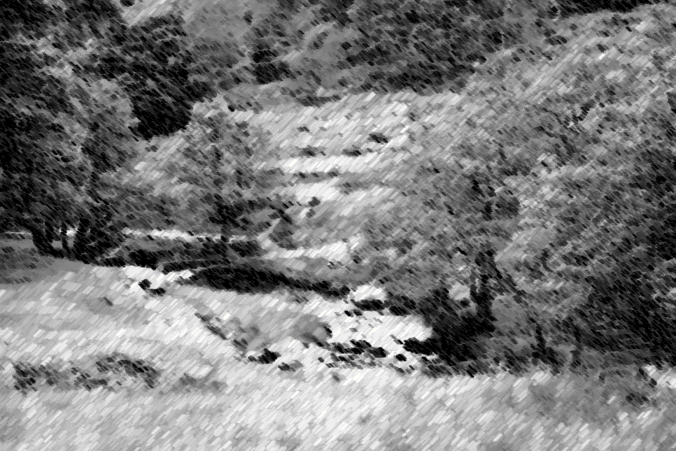

A much wider valley and more gentle slope

Interception from the trees slows the movement of water into the rivers

Small bed load, rounded, slip off slope

Width becomes much wider in the lower course and land is flatter creating flood plains.

