HW4 – Year 9 Population – Migration
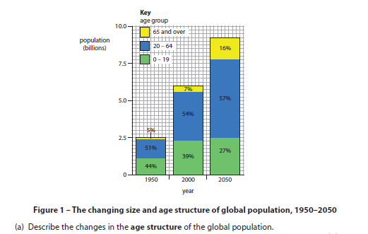
Q1- Describe the changes in population structure from 1950 to 2050?

Q1- Give two reasons why population has changed like the pattern on the graph?

